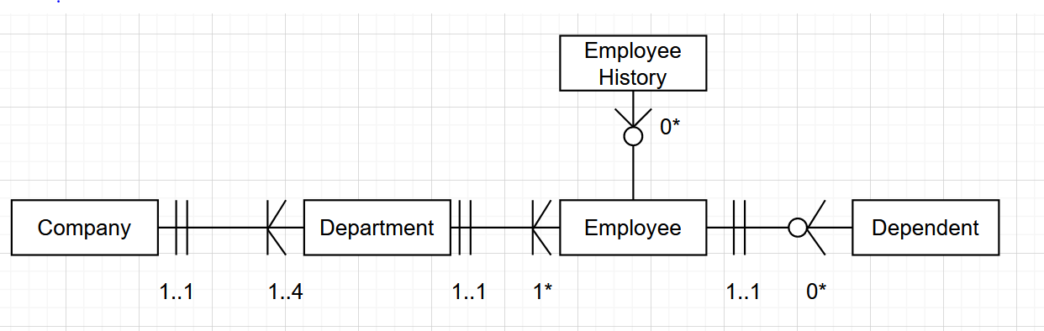

(Corrected version including proper symbols)

(note to self: Question said 1 company has 4 department and 1 department belongs to 1 company. Thus in diagram, we need to give 4 towards to department side and 1 towards to company side! Do not reverse the order!)